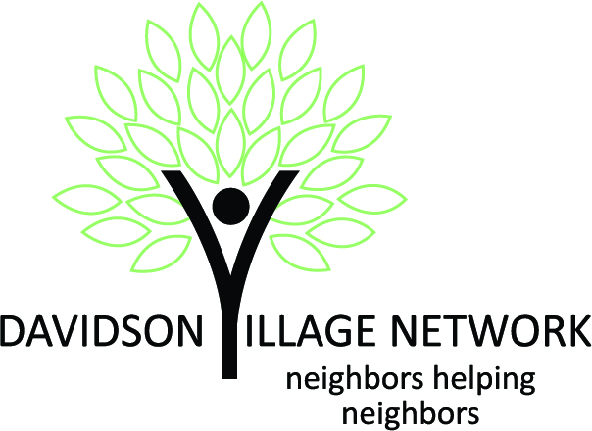
Service Volunteer Application
Please mail completed application to DVN c/o Ellen Giduz, P.O. Box 443, Davidson, NC 28036 or email it to elgiduz@gmail.com or leave it for Ellen Giduz the Davidson Public Library. Thank you!
We’re delighted that you are interested in volunteering with the Davidson Village Network (DVN), and we appreciate your willingness to share your time and skills to improve the lives of our members. The Davidson Village Network is a non-profit organization dedicated to enhancing the lives of its members through a menu of services and programs enabling them to live healthy, meaningful lives in their own homes and communities.

Volunteers are critical to the success of DVN. The more we know about you, the more we can ensure that your volunteer experiences are meaningful and of value. Please feel free to provide any supplemental information on the back of this form. We look forward to speaking with you.

____ ______
Last Name First Name Middle Name Preferred First Name

________
Other legal names used, e.g. legal name changes

________
Address City Zip Code

________
Phone Email

What is generally the best way to reach you? ______Phone ______Email

How did you hear about us? ___________________________________________________________________________

AVAILABILITY
What volunteer time would you be comfortable giving to DVN? Check all that apply:
 | No | Yes | If Yes, any additional qualifiers/restrictions:
Ad hoc assignments arranged ahead of time?
Regular time slot(s), weekly/bi-weekly/monthly, etc.?
“On call” as available?
Specific availability will be established directly with you after your application is approved. We prefer that you fulfill a minimum of two service requests per month.

SKILLS AND INTERESTS
 | No | Yes | If Yes, please describe:
Have you ever worked with seniors?

Do you have any other volunteer commitments?

Are you a member of any community organizations that you would care to mention?

If you have a special skill or interest (e.g. yoga or current events) that you would be willing to share with Members in a larger setting, please list them.
Do you speak other languages? If so, what are they?

SERVICE ACTIVITIES

Please check any of the services listed below that you would like to provide.

Transportation  ☐Driving to & from the store  ☐Driving to & from appointments  ☐Driving to & from personal activities  ☐Driving to & from DVN events | Companionship  ☐Daily / Periodic phone checks  ☐Friendly visits  ☐Reading aloud  ☐Accompanying to social activities
General Personal Services  ☐Occasional light cooking  ☐Meal delivery  ☐Occasional pet care  ☐Decluttering / Organizing on a small scale  ☐Walks / Light Exercise | Simple Home Maintenance  ☐Occasional light cleaning / housework  ☐Light yard work / Gardening  ☐Changing hard to reach bulbs  ☐Hanging pictures  ☐Use of indoor ladders  ☐Mattress turning  ☐Simple repairs  ☐Moving outdoor furniture
Running Errands  ☐Grocery shopping  ☐Picking up prescriptions  ☐Other errands, e.g. dropping off or picking up  dry cleaning, library books, packages, etc. | Events  ☐Help with planning, check in, set up and clean-up for DVN social events  ☐Present a program or class  ☐Lead an activity  ☐Recruit program presenters
Technical Assistance  ☐Set up / program cell phone and other gadgets  ☐Provide basic computer assistance | Be a Service Volunteer Assistant  ☐Data entry  ☐Answer phone & relay information / messages  ☐Monitor & respond to messages  ☐Make volunteer assignments  ☐Assist with volunteer intake  ☐Train volunteers  ☐Coordinate Service Volunteers
Are there any types of volunteer activities you would prefer to avoid?
There are also other volunteer opportunities with DVN. These positions are for volunteers who do not provide direct services to members, but rather assist the organization in some way. Check any that interest you and we will refer you to the right person to talk to.
- Membership Volunteer
- Grant Writer
- Marketing Volunteer
- Fund-Raising Volunteer
- Secretary to the Board of Directors
Are there other services you would like to provide that you don’t see listed? If so, please jot them down here.

DRIVING (If not volunteering to drive, you may skip this section)
To transport DVN members, you must maintain a valid North Carolina driver’s license and vehicle registration, maintain automobile insurance coverage, and sign and agree to the Volunteer Driver Policy.
________
Driver’s License # Auto Insurance Carrier
________
Auto Insurance Policy # Amount of liability coverage
__________________________________________________________________________________________________________________________
License plate number and expiration date Date of last NC safety & emissions inspection
Are you willing to drive another person’s car? Yes____ No____
I agree to drive safely, to obey all traffic laws and to be free of the influence of alcohol or drugs when I transport DVN Members or Volunteers. In the event of an accident while driving a Member or Volunteer, I agree to submit to a drug and/or alcohol test if requested.
__________________________________________________________________________________________________________________________
Signature Date Witness

VOLUNTEER PRIVACY INFORMATION AND RELEASE AUTHORIZATION FOR BACKGROUND CHECKS
Please read the following carefully:
Application information
I certify that all information in this application is true and complete. I understand that any false information or omission may disqualify me from further consideration for volunteer service and may result in my dismissal, if discovered, at a later date.
Background investigation
I understand, in consideration of my application, a background investigation will be conducted. I understand this investigation may include, but is not limited to, a criminal background check in the files of any Federal, state or local justice agency, driving history, or reference verification. Drug screening may be performed if I have an accident while driving for Davidson Village Network. I authorize Davidson Village Network to conduct the background investigation and release Davidson Village Network from responsibility for this investigation. I understand the requested information is for the sole purpose of gathering accurate information for volunteer services at Davidson Village Network.

 | No | Yes | If Yes, please explain:
Have you ever been convicted of a criminal offense?

I have read and understand the above and by my signature, I consent to these statements.

______________________________________________________________________
Applicant Signature Date

If under 18, parent or guardian must give permission:
I give my consent for ________________________________________to serve as a volunteer in the Davidson Village Network according to all applicable policies set forth in this agreement.

________________________________________________________________________________________
Signature Date

________________________________________________________________________________________
Printed Name Relationship
Please mail completed application to DVN c/o Ellen Giduz, P.O. Box 443, Davidson, NC 28036 or email it to elgiduz@gmail.com or leave it for Ellen Giduz the Davidson Public Library. Thank you!

